Questions and Appeals
The American Board for Occupational Health Nurses, Inc., (ABOHN) provides an opportunity for candidates to question any aspect of the certification program. ABOHN will respond to any question as quickly as possible. Candidates are invited to call 630-789-5799 or send an email message to info@abohn.org for any questions. In addition, ABOHN has an appeals policy to provide a review mechanism for challenging an averse decision, such as denial of eligibility for the examination or revocation of certification. Am application for an appeal is available online at www.abohn.org
It is the responsibility of the individual to initiate the appeal processes by written request or completing the form and sending it to the ABOHN Executive Director within 30 calendar days of the circumstance leading to the appeal.
Please mail the form to:
Address: ABOHN
7250 W College Dr #2SW
Palos Heights, IL 60463

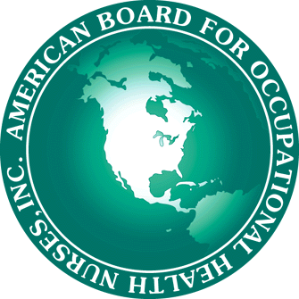
ABOHN Appeal Form
Date: ____________________________
Individual Requesting Appeal:
Name: ________________________________________________Cert #_________________
Address: _____________________________________________________________________
City, State, Zip: _______________________________________________________________
Phone Number: _______________________________________________________________
Reasons for Review:
Application Criteria Change in Application Status
Exam Failure Recertification Criteria
Problems with fees Other
Additional information for appeal: __________________________________________________________
______________________________________________________________________________
______________________________________________________________________________
______________________________________________________________________________
______________________________________________________________________________
_____________________________________________________________________________________
Upon receipt of a request for appeal, the Appeals Panel will review the case at its next scheduled appeals review. The decision of the Appeals Panel shall be final.
Candidates will be notified in writing of the Appeals Panel’s decision.
For questions about the review and appeals process please call the American Board for Occupational Health Nurses at (888) 842-2646.

