Congratulations!
It takes a special kind of commitment to become a "COHN”, “COHN-S” or "CM"!
Occupational health nurses who have achieved the right to use these credentials have demonstrated knowledge, experience and leadership in their specialty. Attainment of this mark of excellence can now be recognized by a COHN or COHN-S pin which is available only to occupational health nurse who have been certified by the American Board for Occupational Health Nurses, Inc. (ABOHN). The official pin is crafted in your choice of either 10K gold filled or solid 10K gold with a teal border. In addition to the pin, a guard that spells COHN, COHNS or CM can be purchased to wear with the ABOHN pin or another pin.
The pin, guard and ring are available only through ESCO. To order you emblem of certification, fill out the order form and return it with your check or money order payable to ESCO. Again, congratulations...you've earned the recognition you'll receive by wearing it!
Prices based on a $1400.00 Fine Gold Market
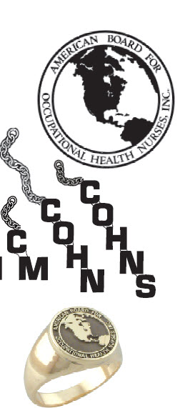
Qty. Description Price
Pins:
*ABOHN pin and guard combination discount.
**Tackette back available for all of the above.

ABOHN Pin with COHN Guard*
____ 10K Goldfilled ............................................$95.00
____ Solid 10K Gold ........................................$347.00
ABOHN Pin with COHNS Guard*
____ 10K Goldfilled ............................................$95.00
____ Solid 10K Gold ........................................$347.00
ABOHN Pin with CM Guard*
____ 10K Goldfilled ............................................$95.00
____ Solid 10K Gold ........................................$347.00
Official COHN Guard with chain
____ 10K Goldfilled ............................................$21.50
____ Solid 10K Gold ..........................................$54.00
Official COHNS Guard with chain
____ 10K Goldfilled ............................................$21.50
____ Solid 10K Gold ..........................................$54.00
Official CM Guard with chain
____ 10K Goldfilled ............................................$21.50
____ Solid 10K Gold ..........................................$54.00
Rings:
____ Sterling Silver ..........................................$354.00
____ ESCO Gold .............................................$440.00
____ 10K Gold .................................................$595.00
____ 14K Gold .................................................$876.00
____ Ring Size
*Shipping and Handling ......$12.50 each

TOTAL $_________
(Wisconsin Residents add appropriate sales tax)

ESCO
5300 W. Clinton Ave.
Milwaukee, WI 53223
1-800-852-4266

Please forward this order form with check. money order, Visa or MC in the full amount.
Make checks/money orders payable to ESCO.
Name ____________________________________________
Address __________________________________________
City _______________________________ State _________
Zip _____________ Phone (______)____________________
Card# _______________________________Exp__________
(Please allow four weeks for delivery)

